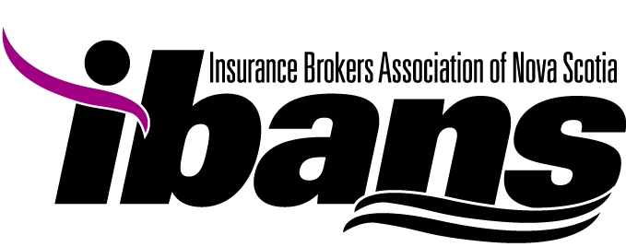
FOR IMMEDIATE RELEASE

RECOGNIZING INSURANCE INDUSTRY PROFESSIONALS
April 15, 2015 – Halifax, NS. The Insurance Brokers Association of Nova Scotia (IBANS) is proud to acknowledge the professional capacity of those working within the industry through its Insurance Awards Program. The program, which is now in its eighth year, recognizes significant peer achievements and promotes best practices in the broker community.
At an awards dinner hosted last evening both award recipients and nominees were recognized for their contributions to the industry as well as the positive way they have impacted their communities, furthering the integrity and strength of the broker distribution channel. There are six award categories representing achievements by both individuals and brokerages. They include: Client Service Award; Insurance Representative of the Year Award; Young Broker of the Year Award, Volunteer Service Award, Professional Development Award and Brokerage of the Year.
“The awards program provides an opportunity to recognize not only established industry leaders but showcases new talent entering the broker profession” says Glenna Boudreau, President, IBANS.
We proudly recognize our six award recipients.
Individual Award Recipients
Patricia Calder | Client Service Award | MacLeod Lorway Insurance Group
Robert (Bob) Wrye | Insurance Rep of the Year | Portage Mutual Insurance
James Mizzi | Young Broker of the Year | Macdonald Chisholm Trask Insurance
Robert Wilson | Volunteer Service Award | R.K. Wilson Insurance Services Inc.
Brokerage Awards
Founders Insurance Group Inc. | Professional Development Award
Anderson Brown Company Insurance | Brokerage of the Year

-30-
For more information, please contact:
Karen Slaunwhite,
Executive Director
Insurance Brokers Association of Nova Scotia
902-876-0526 or karen@ibans.com
www.ibans.com

